What is ecg?

* An electrocardiogram is a commonly used device in medicine which is normally used to give medical professionals an approximation of the heart’s electrical conductivity.
* Specific leads are placed on the skin hence the name surface ECG and these leads are placed to measure the electrical currents produced by the heart and conducted across the body.
* The standard practice for taking an egg involves using 10 cables/electrodes to in order to get a 12 lead surface A person with red hair and red hair with acupuncture needles

  Description automatically generated
* The leads labelled v1-v6 are placed on the chest and cover the areas closest to the heart seen in this figure, each v represents an electrode placed on the chest..
* The other leads are all placed on the extremities and hold the labels : I, II, III, aVR, aVL, and aVF , these are calculated from 4 more electrodes three of which are placed on the distal limbs to measure a potential difference between limbs and the one electrode left acts a an ground electrode placed on the spare right ankle as to reduce background noise when recording and ECG **.** The limb leads I – III measure a potential difference between the limbs for example lead I measures the potential difference between the right and left arm , the augmented leads (aVR,aVL,aVF) are calculated by finding the potential difference of one of the three limbs toa n estimate of zero potential. This creates a representation of the vertical plane of the heart as seen in the figure below.
* The standard practice for taking an egg involves using 10 cables to in order to get a 12-lead surface. The leads are then calculated my measuring (Ashley and Niebauer, 2004)
* .
* 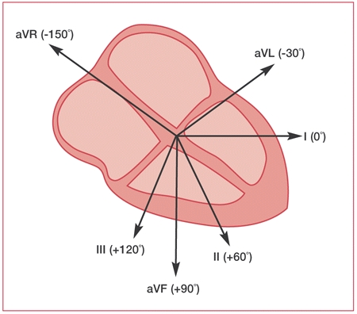
* In this study we focus on four leads as the procedure in which data has been collected resulted in the 4 leads being more well aligned with the intracardiac reading as oppose to the full 12 leads, the four leads chosen where: I , aVF , V1,V6. Both I and V6 represent the lateral surface of the heart while V1 gives signals related to the right atrium and cavity of the left ventricle and aVF is related to the inferior surface of the heart(Meek and Morris, 2002). Being able to analyse the signals coming from these areas can help identify any abnormalities in the signal and therefore inform cardiologists of what area of the heart is being affected to aid in a diagnosis.

**What does an ECG look like and what does it mean?**

* **A diagram of a graph

  Description automatically generated**
* The figure above gives you a general idea of what and ECG should look like. The P wave acts to represent atrial depolarization which then can lead on to depolarization of the ventricles seen in the QRS segment. We expect and hope the QRS will be small to represent a efficient depolarization of the ventricles, however wider QRS may suggest less efficient depolarization suggesting dysfunction in the heart. Finally , a plateau is reached of the myocardial action potential and at this point the ventricles contract and pump blood around the boody(‘ECG interpretation: Characteristics of the normal ECG (P-wave, QRS complex, ST segment, T-wave)’, no date).
* During Atrial fibrillation the action potential are fired at exceedingly fast rate from 400 to 600 beats per minute, the speed of this action potential means the threshold for the activation of the ventricles to fill up an contract is not always met and therefore reducing ventricular activation and subsequently presenting as a reduced amount of QRS waves relative to P waves. This presents itself in an ECG with a less than 1:1 ratio of p waves to QRS waves typically show up as an irregular amount of p waves followed by QRS dispersed irregularly through the reading. The figure below shows an example of the irregularity of the QRS waves seen by inconsistently placed peaks(*Atrial Fibrillation ECG Review*, no date).
* **A graph with a line drawn on it

  Description automatically generated**